CSS: Cascading Style Sheets

Cascading Style Sheets (CSS) is a style sheet language used for describing the presentation of a document written in a markup language like HTML. CSS is a cornerstone technology of the World Wide Web, alongside HTML and JavaScript.

CSS is designed to enable the separation of presentation and content, including layout, colors, and fonts. This separation can improve content accessibility, provide more flexibility and control in the specification of presentation characteristics, enable multiple web pages to share formatting by specifying the relevant CSS in a separate .css file, and reduce complexity and repetition in the structural content.

Separation of formatting and content also makes it feasible to present the same markup page in different styles for different rendering methods, such as on-screen, in print, by voice (via speech-based browser or screen reader), and on Braille-based tactile devices. CSS also has rules for alternate formatting if the content is accessed on a mobile device.

<Style> tag:

The <style> tag is used to define style information for an HTML document. Inside the <style> element you specify how HTML elements should render in a browser. Each HTML document can contain multiple <style> tags.

Syntax:

A CSS rule-set consists of a selector and a declaration block:

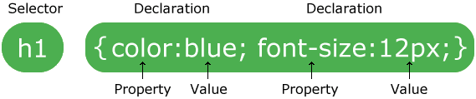

The selector points to the HTML element you want to style.

The declaration block contains one or more declarations separated by semicolons.

Each declaration includes a CSS property name and a value, separated by a colon.

A CSS declaration always ends with a semicolon, and declaration blocks are surrounded by curly braces.